Origami Jumping Frogs
Materials
- Origami paper
  - A square piece of any paper will work, but origami paper works best.
  - If you use 6 x 6 inch paper, your frog will be 2 x 2 inches.
​
Steps
- When you see arrows, those are showing you which direction you should fold the paper, and the dotted lines show you the line the fold will make. Remember, you are not folding to match the paper up with the dotted line, you are folding ON the dotted line:
​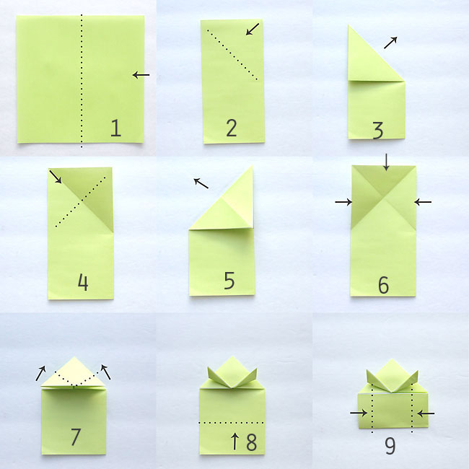
​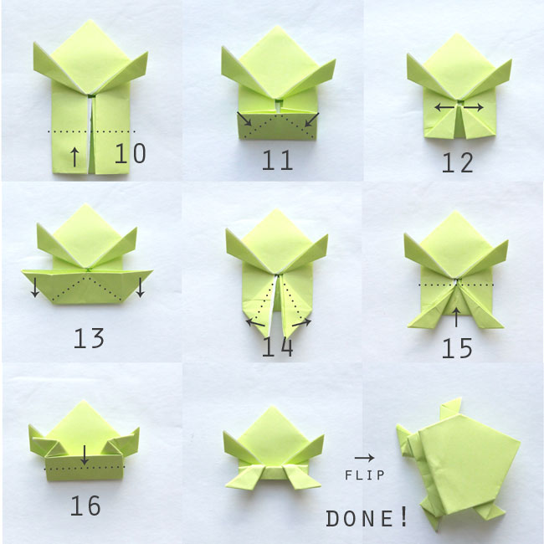

​Once your frog is folded, press down on the folded “legs” with the tip of your finger, then quickly slide your finger off to make the frog jump.
  - Depending on how hard you push the legs down, you might be able to get the origami frog to make one perfect flip in the air and land on its feet again.
  - Try to jump the frogs into targets, or see whose frog jumps the furthest.
​
https://www.itsalwaysautumn.com/origami-jumping-frogs-easy-folding-instructions.html

